Video Encoding – Geo Encryption Algorithm

line 1: 1st Given Name Surname   
line 2: *dept. name of organization   
(of Affiliation)*  
line 3: *name of organization   
(of Affiliation)*line 4: City, Country  
line 5: email address or ORCID

line 1: 4th Given Name Surname  
line 2: *dept. name of organization*  
*(of Affiliation)*  
line 3: *name of organization   
(of Affiliation)*line 4: City, Country  
line 5: email address or ORCIDline 1: 2nd Given Name Surname  
line 2: *dept. name of organization   
(of Affiliation)*  
line 3: *name of organization   
(of Affiliation)*line 4: City, Country  
line 5: email address or ORCID

line 1: 5th Given Name Surname  
line 2: *dept. name of organization   
(of Affiliation)*  
line 3: *name of organization   
(of Affiliation)*line 4: City, Country  
line 5: email address or ORCIDline 1: 3rd Given Name Surname  
line 2: *dept. name of organization   
(of Affiliation)*  
line 3: *name of organization   
(of Affiliation)*line 4: City, Country  
line 5: email address or ORCID

line 1: 6th Given Name Surname  
line 2: *dept. name of organization   
(of Affiliation)*  
line 3: *name of organization   
(of Affiliation)*line 4: City, Country  
line 5: email address or ORCID

**Abstract –**

**Video encoding deals with the video encryption and compression. This paper proposes a symmetric block algorithm with key size of 128-bits to effectively encrypt the video files to make is secure and fast enough for transmission and storage. The proposed algorithm reads the video file as bytes and maps blocks of bytes to a point on a Geometrical 2-D plane. Using the key from the Code-Book, which is shared between the communicating parties the encrypted data can be decrypted at a fast rate as well. As the algorithm would be a Fully Layered Encryption technique it wont effect the MPEG**

**Data Security is one of the biggest concerns of the free world. Cyber-warfare and cyber-attacks are now more dangerous for a country or an organisation than any other form of attacks. Data protection has now become important more than ever. With the recent advances in the field of supercomputers and the attacks that are being made to crack the existing algorithms like the Advanced Encryption Algorithm (AES), this paper proposes a new algorithm that will randomise the data to arbitrary points on a 2D plane and generate a random key for each point. The algorithm proposed is fast and more secure than the currently used encryption algorithms.**

**Introduction**

With increasing bandwidth capabilities around the globe and several platforms providing support for live streaming, ensuring real time security has become a matter of prime importance. The pace at which data is being generated and transmitted today has never been seen in the past. As a lot of this data is being generated by end users, data security at individual level is much needed.

As far as text data is concerned, several algorithms such as AES, 3DES, Blowfish, etc are used for efficient and secured encryption. On the other hand, algorithms to encrypt multimedia(videos) are comparatively not as efficient. As multimedia needs to be encrypted, compressed, transmitted, decompressed, decrypted in real time, algorithms involved must provide higher throughputs. To accomplish this, several techniques are devised which have their own disadvantages which have been discussed as follows.

1. Fully Layered Encryption : The video file is compressed and encrypted using standard algorithms like AES. Though this technique is quite secure, but it is slow and therefore cannot be used in real time applications.
2. Selective Encryption : Only some bytes of data are selectively encrypted using standard algorithms to allow real-time processing. This is less secure as some glimpse of images are found to be visible after encryption.
3. Permutation based Encryption : A permutation list is used as a secret key to scramble some bytes of the video contents. This technique compromises on security as the data is not changed but only scrambled.
4. Perceptual Encryption : This technique partially degrades the quality of audio/visual data that it is understandable but still the attacker would prefer for an authentic one. The data after encryption is not really hidden but is just degraded, the technique cannot be used for sensitive data.

Apart from the situational disadvantages discussed above, all techniques except the Fully layered Encryption are vulnerable to known plain text or/and known cipher text attack. Some of these techniques are not MPEG complaint and thus need specialised codecs (hardware or software). Thus, the literature survey suggests a need for a more secure algorithm that has a better throughput. This paper proposes an algorithm that can be used for Fully Layered Encryption as it provides enough throughput to make it viable for real time applications.

The algorithm proposed in this paper gives higher throughput, security and compatibility as it has the following salient features: *(i)* uses multiple keys instead of heavy computation to ensure security; *(ii)* encrypts bytes instead of frames so can be used for Fully Encryption technique in a MPEG compliant way; *(iii)* maps blocks of data to points in X-Y plane in one-to-many relationship to provide security against known plain text attacks.

The paper discusses algorithm’s compatibility with MPEG codecs in Section I, Parameters affecting algorithm security and their relations in Section II, Core algorithm in Section III, Discussion about padding, compression, parallelization in Section IV, Performance analysis and Attacks in Section V, and Conclusion in Section VI.

**I Compatibility with MPEG codecs**

Several versions of MPEG codecs ranging from MPEG-1 being the first release to MPEG-4 AVC (H.264) being the latest one, have been into practice. Over the years, the encoding techniques of these versions have evolved to provide better throughputs and compression. In fact, MPEG-4 AVC (H.264) has throughput enough to provide high quality streaming. Most Selective encryption algorithms need to be applied before or during the encoding process. Thus, Selective encryption technique can only use algorithms that can encrypt frames without interfering much with encoding process. but in case of Fully layered encryption, as can be observed in FIGURE X, the data is encrypted after encoding and decrypted before decoding. Not only this makes the algorithm fully compliant with MPEG codecs but also it can be used with existing codec implementations.

**II Parameters affecting algorithm**

This algorithm needs the encrypting party and the decrypting party to agree upon some configuration options, as below.

Block size (*l*): The length of the block in bits, to be treated as one entity while encrypting.

Block Value (V): Value of *l*-bit block on radix 10.

Width (w): The width of the cell.

Key (K): Random bit array of size k.

Key Length (k): The length of key in bits.

Code-Book (CB): A 2-D array index on the x-min and y-min of each cell and stores the key associated with the cell.

Block Value Mapper Bits (BVMB): It will be half the size of the key in bits.

Key Mapper Bits (KMB): This will decide the key.

**III Core Algorithm**

*Encryption -*

The most used algorithms today such as, AES, Elliptic Curve, 3DES, etc all have a basic idea of replacing a character by another and/or use prime numbers in computation process. This makes these algorithms computationally heavy and time taking. The idea proposed here is different in these aspects, i.e. neither does it map a character to another, nor does it use prime numbers.

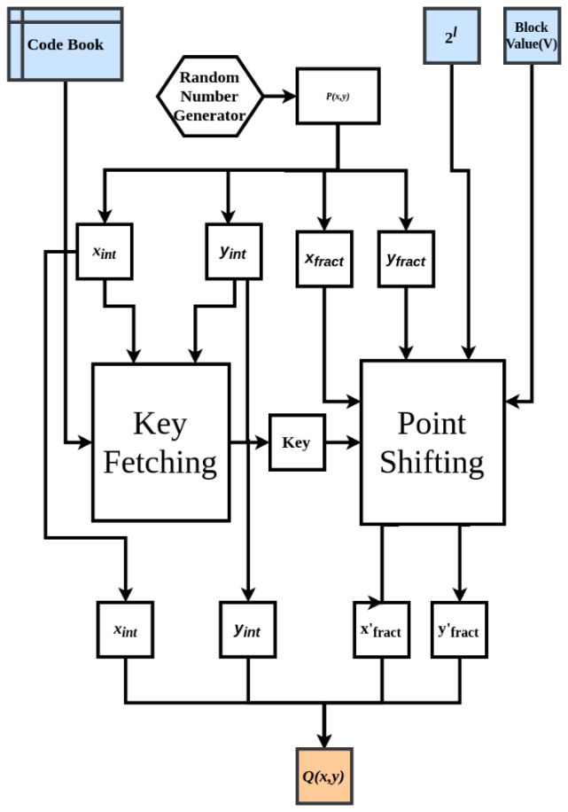

Figure 2: Encryption

If the encryption function is represented mathematically, one gets the bellow equation.

f(b): B→G

where,

B: A set of blocks of size *l.*

G: The X-Y plane with total cells *n* and width *w*.

When describing B, a set of blocks of a given block size infers that B is a set of bit arrays, each of length *l*. For example, if *l* =32, B is a set that comprises all the values from 0 to 232 - 1 in binary, formatted to 32bits with leading zeroes. G can be viewed as a plane with grid as shown in Fig 1. Each cell of this grid has associated with itself a random key. The key length (k) in bits is twice the size of block (*l*). All the points in each cell will only use the associated key of that cell while encryption and decryption.

k = 2 * *l*

Where, k: Key length *l*: Block size

The Point (P) which would be represented using (*x, y*) would have four values. The integer part of *x* and *y*, and the fractional part of *x* and *y*. As the algorithm maps a block to a point P (*x*, *y*), the encryption process can simply be described as “To find a random point that maps to the desired block value”. To achieve this, a random point is selected and then shifted such that it represents the desired block value. As the randomly selected point decides the key value it is necessary that the point does not shift to another cell, and in-process change the key. So, while shifting it is noted that only the fractional part changes leaving the integer part intact. Due to this the fractional part is ignored while fetching the key from the Code-Book and integer part is ignored while shifting. As the key fetching and the point shifting depends upon distinct parts of *x* and *y*, point P can be represent as,

*P (xint, xfract, yint, yfract)*

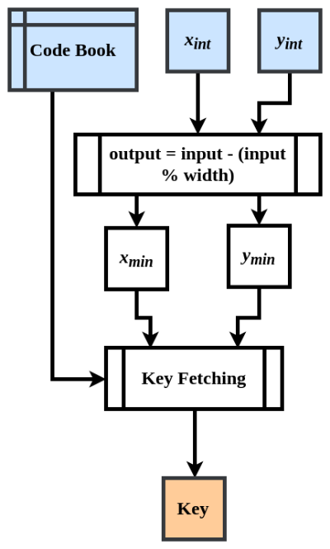

Figure 3: Fetching the Key

*Key Fetching –*

To fetch the key, we need to find the cell in which the randomly selected point lies. As the grid is of uniform width (w) and the Code-Book is indexed on the minima of each cell, the key can be located as,

K = CB [*xint* – (*xint* mod w)] [*yint* – (*yint* mod w)]

Now this key is used in encrypting the upcoming block of the data. The fractional part of the x and y are also random points which are concatenated together and then a XOR operation is performed on them with the key. Length of α is going to be same as that of the key.

α = (fract(x) ● fract(y))

β = α ⊕ Key

The α value needs to be adjusted such that it represents the block value to be encoded. So, on adding the offset to β and again operating a XOR operation on it with the key,

γ = β mod 2*l*

offset = γ – V

β*'* = β + offset

α*'* = β*'* ⊕ Key

it gives a value α', which is then split into two values. The first half represents *x'fract* and the second half represents *y'fract*. These bits have the encoded data in them.

*x'fract* ● *y'fract* = α*'*

The *x'fract* and *y'fract* values are now merged with the integer parts of x and y that were selected randomly in the very beginning of the algorithm, thus retaining the key location on the grid and hiding the intended data.

*P(xint,xfract,yint,yfract)****→****Q(xint,x'fract,yint,y'fract)*

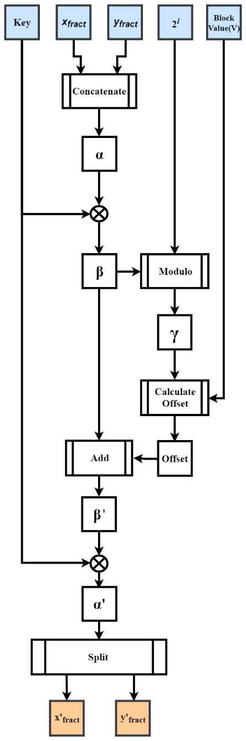

Figure 4: Shifting the Point P to Point Q

Each block is written serially in its encrypted format in a binary file which can then be shared over the network to the intended receiver (decrypting party).

*Decryption –*

The decryption process starts with the encrypted point (Q) as input. As the integer portion of the Point P does not change while encryption, the key-fetching for decryption can be done in the same way as in the encryption process. Once the key is fetched, the block value can be retrieved from the fractional portions of Point *Q(xint,x'fract,yint,y'fract)* by backtracking.

α = (*x'fract* ● *y'fract*)

β = α ⊕ Key

V = β mod 2*l*

V here is the block value that the sender intended to send to the receiver. The block bits can be obtained by formatting V to *l* bits size with leading zeroes.

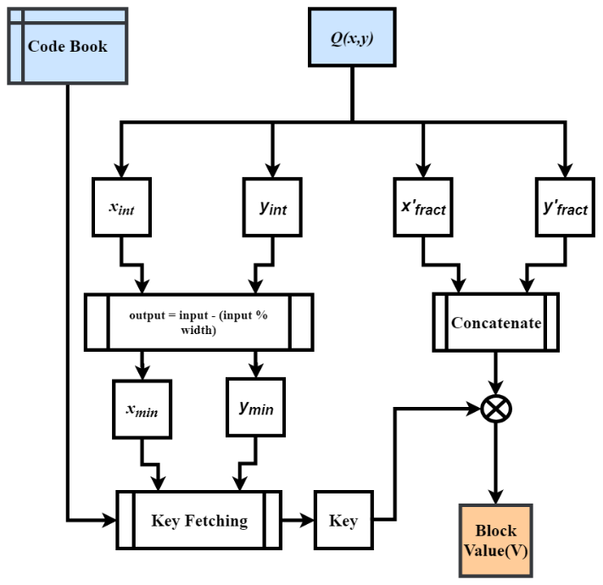

Figure 5: Decryption Process

**IV. Discussion**

*4.1 Padding*

In an ideal case, each file will have file size divisible by block of size; but in real time scenario, this is rarely the case. For the algorithm to work on any file size, a padding needs to be appended in the encrypted file. In this case the padding is the number of bytes in the last block.

For example, let’s consider a file size of 1029 bytes to be encrypted with block size of 8 bytes (*l =* 64 bits), then the last block will have 5 bytes of data. This makes the padding value to be 5. This value is appended in the beginning of the encrypted file. So, during decryption the encrypted file is read, and this value is used to cut short the last block of the decrypted data appropriately.

4.2 *Random Number Generator*

In any encryption algorithm, randomness/entropy is of prime importance. Many implementations of Random number generators are not purely random and so are prone to attacks. While key and point generation, it is necessary that proper randomness is ensured. During testing of the proposed algorithm, Pythons Secret library is used for the key generation and the boost library of C++11 is used get random Points.

4.3 *Parallelization*

As each block uses a distinct key, there is no need for chaining as is in AES and other algorithms. The encryption process of each block is isolated from other blocks. This makes the algorithm highly parallelizable. While testing, OpenMP of C++ was used for parallelising the algorithm which increased the performance two times on a dual core CPU.

4.4 *Compression*

Although the encoding process in theory is a compression process, on using the proposed algorithm the size of the encoded file becomes thrice. As while encryption the blocks of data change to points in X-Y plane, the encrypted file can be compressed again. As the paper discusses about video streaming, the compression algorithm to be used should be able to efficiently compress smaller chunks of data. While testing, library Z-std was used to compress the encrypted file.

**V. Performance analysis and Attacks**

5.2 *Performance Measure*

As discussed above, the algorithm is parallelisable and does not use prime factorization, this makes the algorithm computationally fast. When tested on a machine with 64-bit, i7 processor with 4 logical processors, 6500U CPU @ 2.5GHz, 8GB RAM, the results obtained were as shown in Table 1 below.

Table 1: Performance Measure

|  |  |  |  |  |
| --- | --- | --- | --- | --- |
| File Size (KB) | Max No. of keys used per iterations | No. of iterations | Total Time Taken | Performance (KB/s) |
| 1 | 128 | 100000 | 19.727 | 5069.19 |
| 10 | 1280 | 10000 | 16.7011 | 5987.62 |
| 100 | 12800 | 1000 | 15.9831 | 6256.60 |
| 1000 | 128000 | 100 | 16.1519 | 6191.22 |
| 10000 | 1280000 | 10 | 16.3845 | 6103.32 |
| 100000 | 12800000 | 1 | 16.9779 | 5890.00 |

While testing file sizes of 1KB to 106KB (~100MB) were encrypted several times to calculate an average performance. The second column in Table 1 describes the maximum number of keys that the algorithm will take for encrypting the file once. Thus, for a 1KB file, around 128 keys each of size 128-bits will be used.

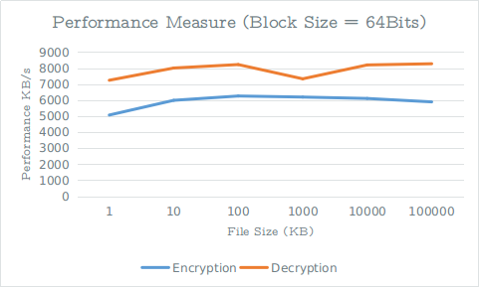

Figure 6: Performance Measure where l = 64

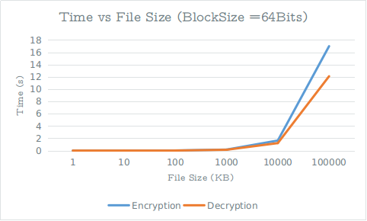

Figure 7: Time taken vs file size

As Figure 6 and 7 depict, the decryption performance is better than encryption performance. Though there is not a major difference but as file size increases the difference becomes observable.

Table 2: Performance(KB/s) when l is 32 and 64

|  |  |  |
| --- | --- | --- |
| Block Size | 32-bit | 64-bit |
| Encryption | 4393.69 | 4589.32 |
| Decryption | 6228.82 | 6064.17 |

The performance with 32-bit and 64-bit block size on a 64-bit, i5 processor with 4 logical processors, 5200U CPU @ 2.2GHz, 8GB RAM was as shown in Table 2 below. As we can see that increasing the block size does not affect much on the performance but increase the security two times.

5.2 *Attacks*

5.2.2 *Brute Force Attack*

For a 64 bit block size the key size is 128 bits. This makes the total number of possible keys to be 2128 which is around 3.4 x 1038. Furthermore, each cell has its own 128 bit distinct key assigned to it, which makes the number of possible combinations to be,

$$n^{2^{128}}$$

Where *n* is the number of total cells in the grid G.  
Hence making the computational complexity of breaking the algorithm very high.

5.2.2 *Known Plain Text Attack*

As each block is mapped on different points of different cells which have different keys associated with them, known plain-text attacks should also not be able to predict the key. The algorithm will be only partially breached even if many keys are predicted somehow. As all the blocks can be mapped to any of the cells therefore, they cannot be associated to any specific defined region of the Grid.

**VI Conclusion**

**VII References**

https://www.eetimes.com/document.asp?doc_id=1279619#